High Cohesion

📌 Definition:
# Source: AI Source: Provided by: [Data Path: Persons Table -> ID Column: 1, Name_En Column: Motasem Essam] -> From: [Chatgpt (GPT‑5 Mini)] on [12/9/2025]
High Cohesion occurs when a class or module is focused on a single, well-defined task, and all its elements work together to achieve that task.

🧠 Simple idea:
# Source: AI Source: Provided by: [Data Path: Persons Table -> ID Column: 1, Name_En Column: Motasem Essam] -> From: [Chatgpt (GPT‑5 Mini)] on [12/9/2025]
“Everything in the class serves one purpose” ✅

🔍 Key characteristics:
# Source: AI Source: Provided by: [Data Path: Persons Table -> ID Column: 1, Name_En Column: Motasem Essam] -> From: [Chatgpt (GPT‑5 Mini)] on [12/9/2025]
- Class/module has one clear responsibility
- ✅ Easier to maintain, test, and reuse
- ✅ Reduces unnecessary dependencies
- ✅ Improves readability and clarity

📊 Example:
# Source: AI Source: Provided by: [Data Path: Persons Table -> ID Column: 1, Name_En Column: Motasem Essam] -> From: [Chatgpt (GPT‑5 Mini)] on [12/9/2025]
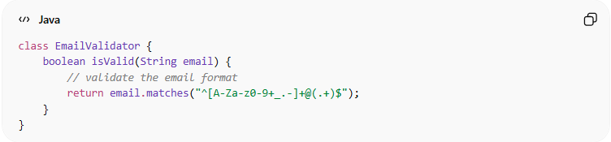
class EmailValidator {
boolean isValid(String email) {
// validate the email format
return email.matches("^[A-Za-z0-9+_.-]+@(.+)$");
}
}
- ✅ EmailValidator only validates emails
- ✅ High cohesion because all methods are focused on one task

⚙️ Best Practice:
# Source: AI Source: Provided by: [Data Path: Persons Table -> ID Column: 1, Name_En Column: Motasem Essam] -> From: [Chatgpt (GPT‑5 Mini)] on [12/9/2025]
- Design classes/modules with single responsibility
- Keep methods closely related to class purpose
- Avoid mixing unrelated functionality in one class
- Promotes high maintainability, reusability, and clarity

